Lab 03

Personas

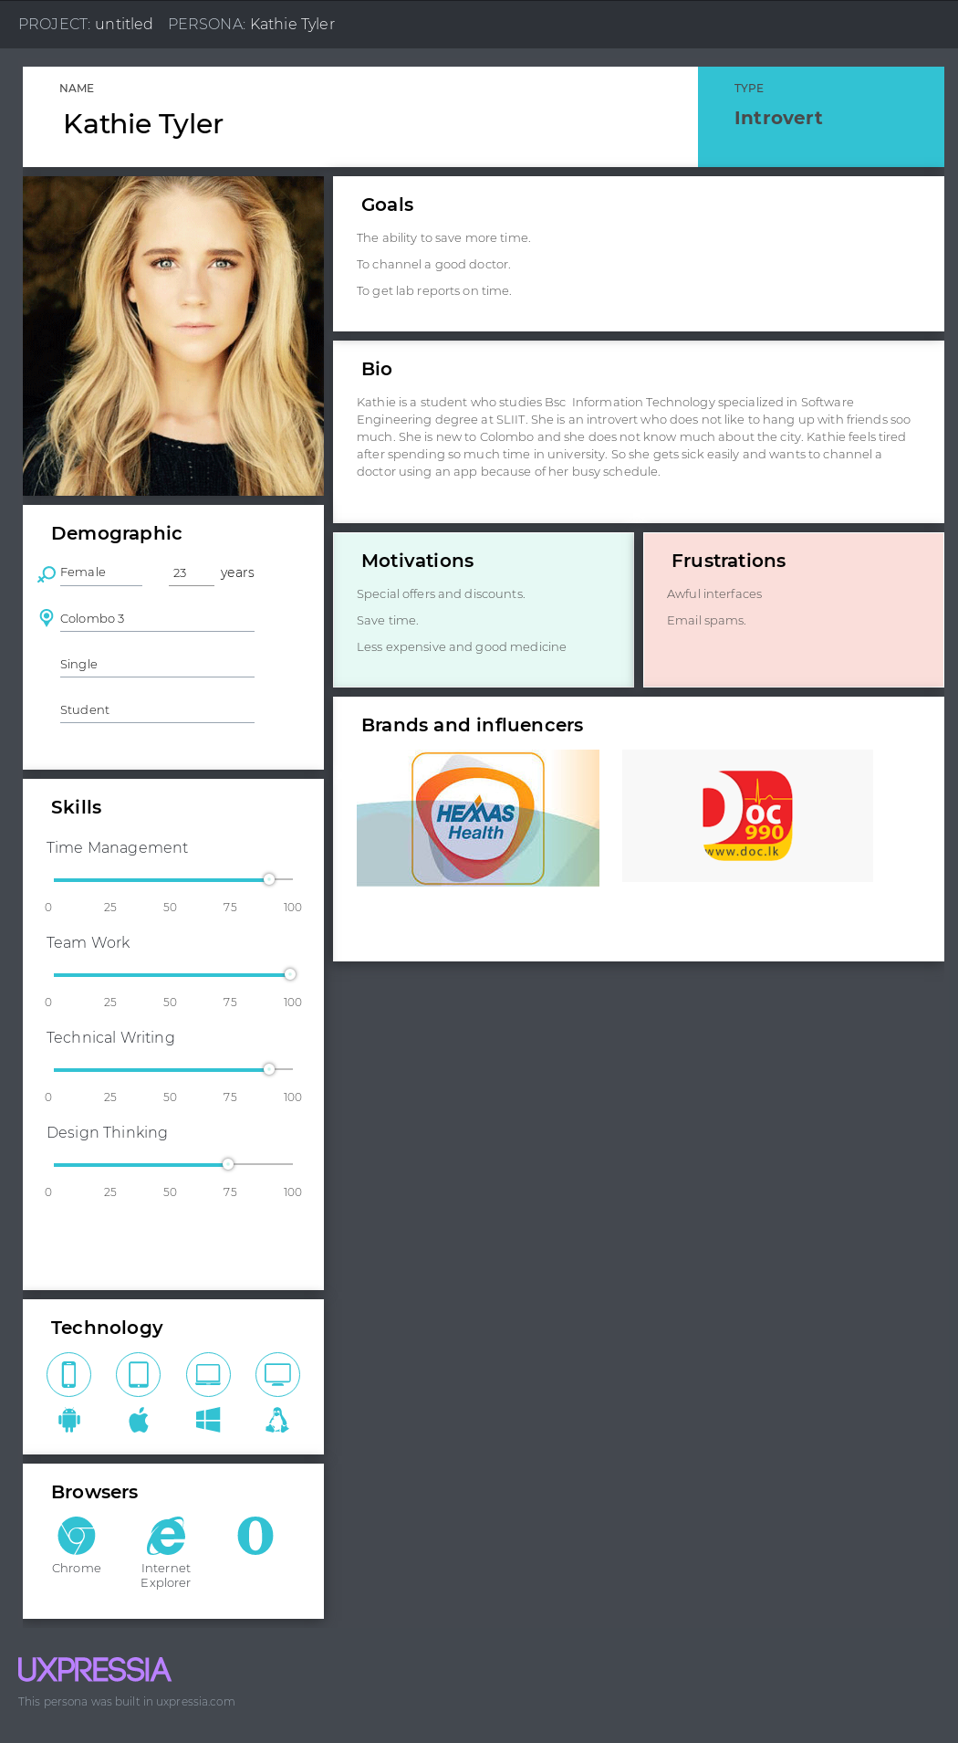

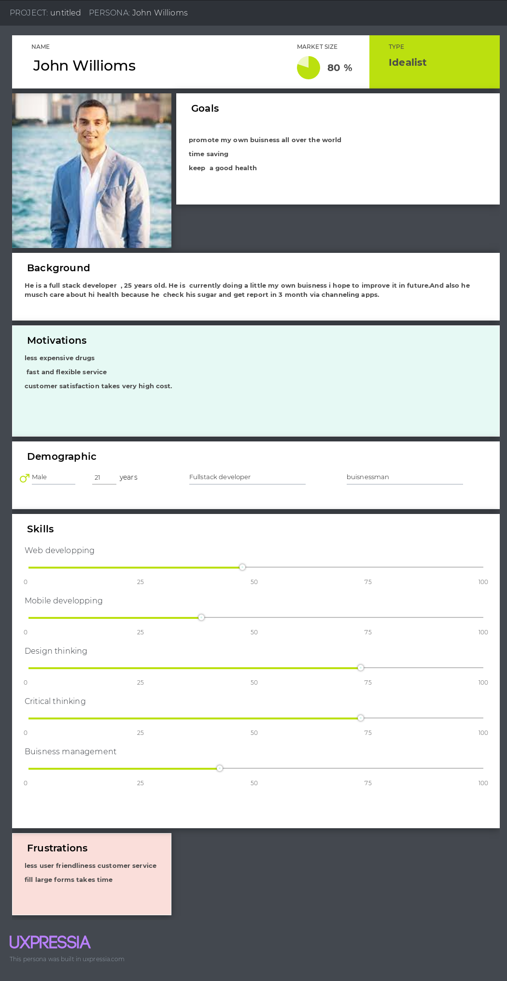

Empathy Maps

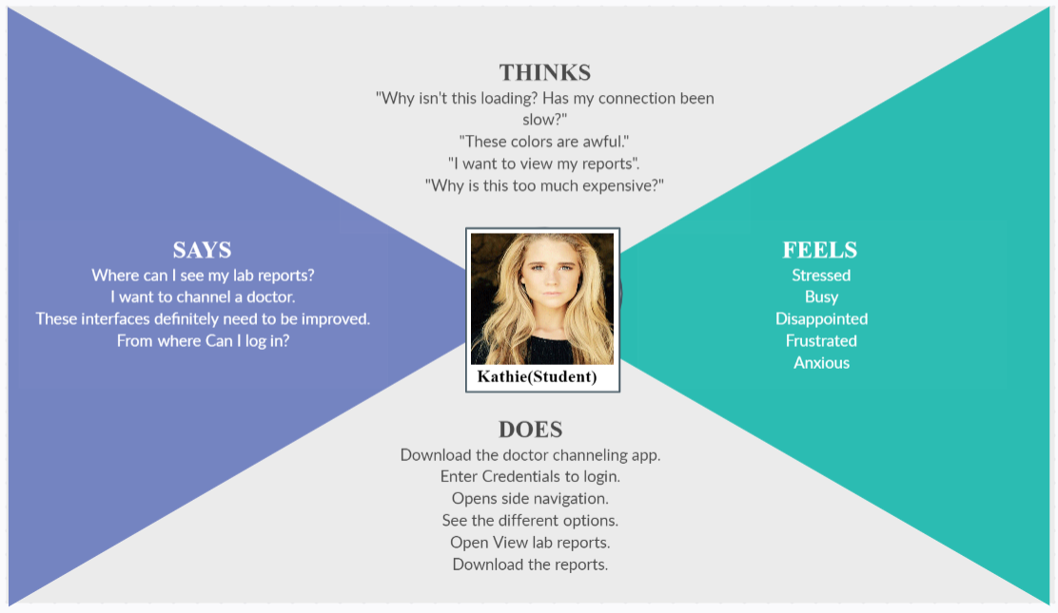

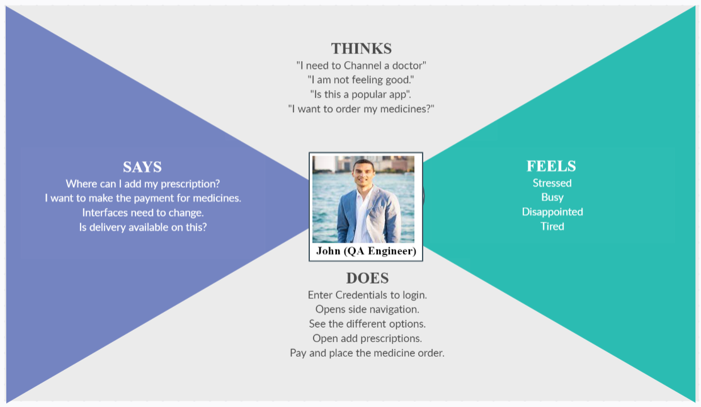

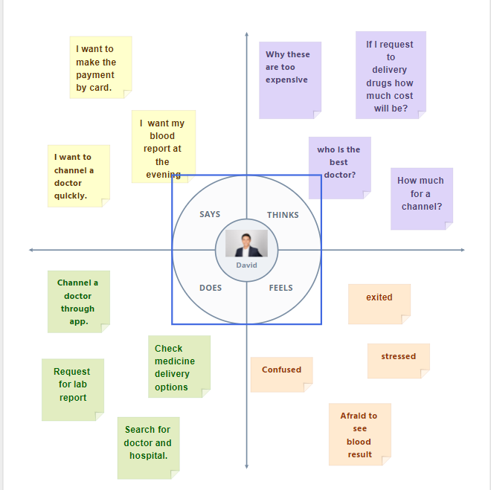

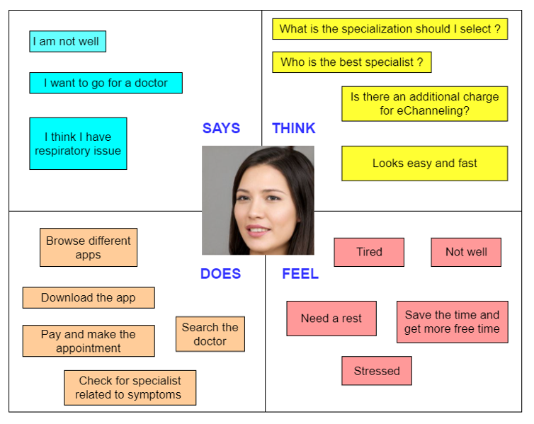

User stories

|  |  |
| --- | --- |
| Kathie | As a user ,I want to be able to register to the app.so that I can view my lab reports and download them. |
| John | As a user, I want to be able to add my prescriptions and then I can order medicines by make the payment via card. |
| David | As a user, I want to make a channel to video consultation, so I don’t want to go to the hospital for channeling. |
| Allen | As a user, I want to be able to search the specialist and make the appointment, so that I can go to doctor without wasting more time. |

User flows

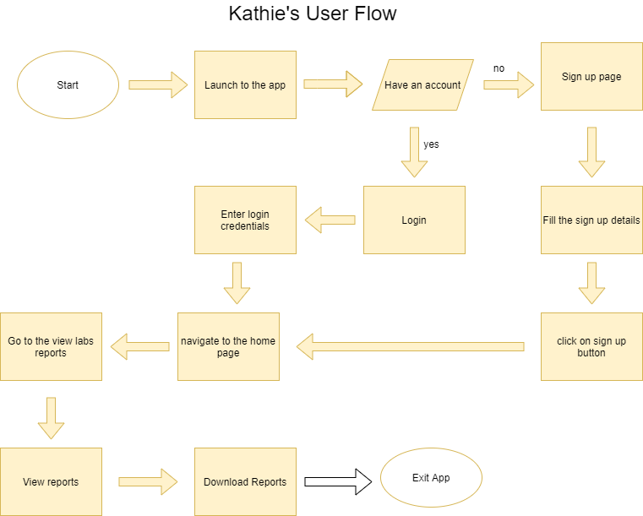

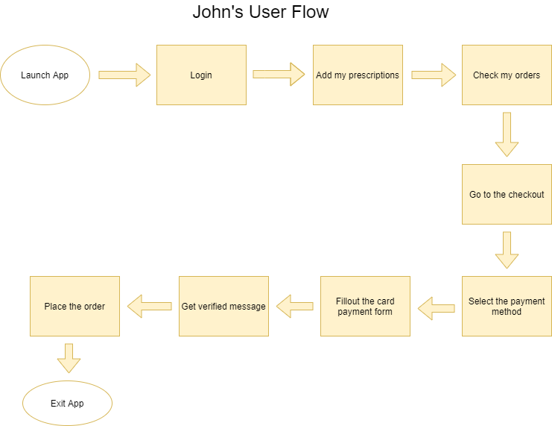

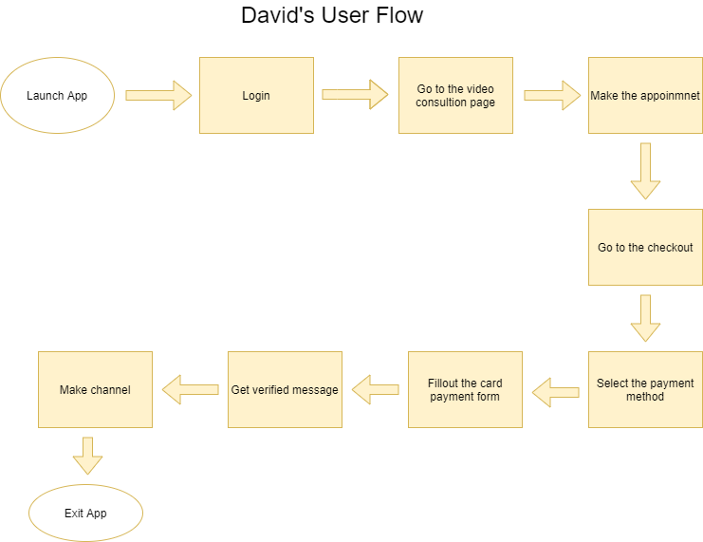

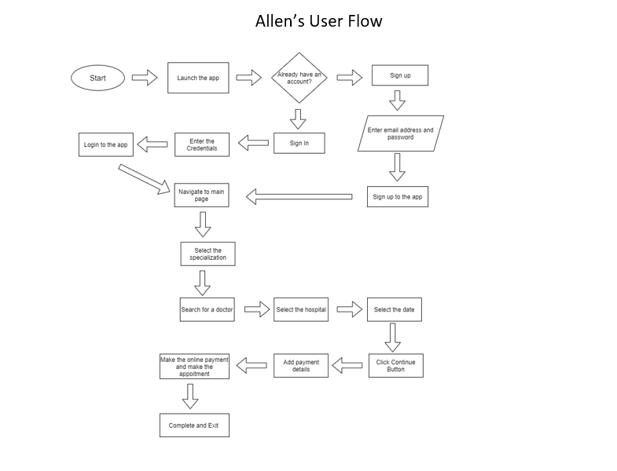

Service Blueprint

